To the Applicant: Thank you for applying to AMA! We look forward to hearing from you and discerning if AMA is the right fit for you. Return completed application to Sandy Piwko at sandy@assumptiocenter.org. Thank you!

If you have questions during the application process, please do not hesitate to contact us using email (sandy@assumptioncenter.org) or phone (508.767.1356.)
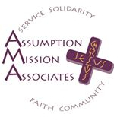

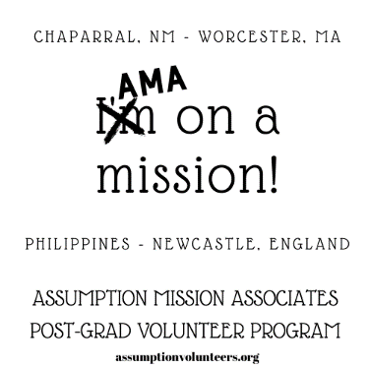

NEW CORK, IRELAND!

PERSONAL INFORMATION
Name ___________________________
Date of Birth______________________ SS#____________________________
Address__________________________________ Apt. ________
_______________________________________________
Preferred Phone___________________________________ (Circle type: Home, Cell, Work)
Secondary Phone ___________________________________ (Circle type: Home, Cell, Work)
Email______________________________________
Home/Permanent Address (if different from above)
Address_______________________________________________ Apt. ________
_______________________________________________
Religious Denomination______ ___________________________
Nationality_____ ______________________________________
Family Members –Parent/Guardian and Sibling Names/Ages

Emergency Contact: Name, address and telephone number of next of kin in the U.S.A.
_______________________________________________________________________
Relationship_________________________
Religious Denomination____ ______________________________
Home Parish/ Worshiping Community Name ________________
Address/Phone_________________________________________
Home__________________________ Cell_________________________
Tell us more about yourself!
List three qualities you would attribute to yourself?

List three activities or hobbies you like to do.
______________________________________________________________________________How would you rate your overall health? Please answer accurately and honestly.
______________________________________________________________________________
Any special diet or have dietary restrictions? ___________________________________________
AMA
How did you hear about AMA? (Please check all that apply)
_____ Catholic Volunteer Network ______ Facebook _____ Twitter
_____ Friend – Name: ________________________________________________
_____ Former AMA – Name: ___________________________________________
_____ Religious of the Assumption – Name: ________________________________
_____ Campus Ministry/ Volunteer Fair
- Other:_ __________________________________

INTENTION FOR SERVICE MINISTRY
For what length of time would you like to volunteer? ____________________________
When will you be available? _____________________________
In your own words, describe the type ministry you are looking for:

Where would you like to serve? Please check all that apply:
____ Chaparral, NM ____ Philippines ____Cork, Ireland
___ Worcester, MA ____ England

EDUCATIONAL BACKGROUND
College/University attended__________________________________
Degrees/Certifications/Years Completed__________________________
Other Institutions of Learning/Programs_____________________________________________
_____________________________________________________________________________
Area(s) of concentration and/or professional skills (Please specify major(s), minor(s), certifications.

______________________________________________________________________________
VOLUNTEER EXPERIENCE
Briefly describe type of work, name and place of organization, dates and duration of experience. You will have more time to speak about these experiences and how they have impacted your life in your interview.

Other Post-Graduate Volunteer Programs to which you have applied:
_____________________________________________________________________________
_____________________________________________________________________________
WORK EXPERIENCE
(Describe type of work, name of employing organization, dates and duration of employment.)

Please indicate any particular skills you may want to offer in your ministry of service (e.g., technical, linguistic, artistic, life skills:

Driving and Criminal History
Do you have a valid driver license? _________________________________
In which state was your driver license issued? __________________________
Driver’s license number ______________________________
For insurance purposes, have you had any driving violations or accidents in the past three years? If so, please list. _________________________________________________________________
Have you ever been convicted of a misdemeanor or felony? If yes, please explain.
____________________________________________________________________________

ESSAYS/ PERSONAL STATEMENT
Here or on a separate page, please respond to the prompts here and on the next page. Feel free to be as concise or as lengthy as you like.
1. Where do you find JOY?
2. How do you connect faith and service?
3. Why do you want to share your life with others for a year or two?

Signature_______________________________________________
Date______________________
To the Applicant:
In addition to this form, if the process goes forward, you will be asked to submit the following:

Self-Evaluation Form
Physical Health Form
2 Letters of Recommendation (1 personal (non-family member), 1 professional)
Conversation with Counselor (or campus health professional)
$10 application fee
If accepted there is a background check required before starting. We will reimburse you upon the document.

Thank your for applying to AMA!

